Configure a servlet in Eclipse IDE.

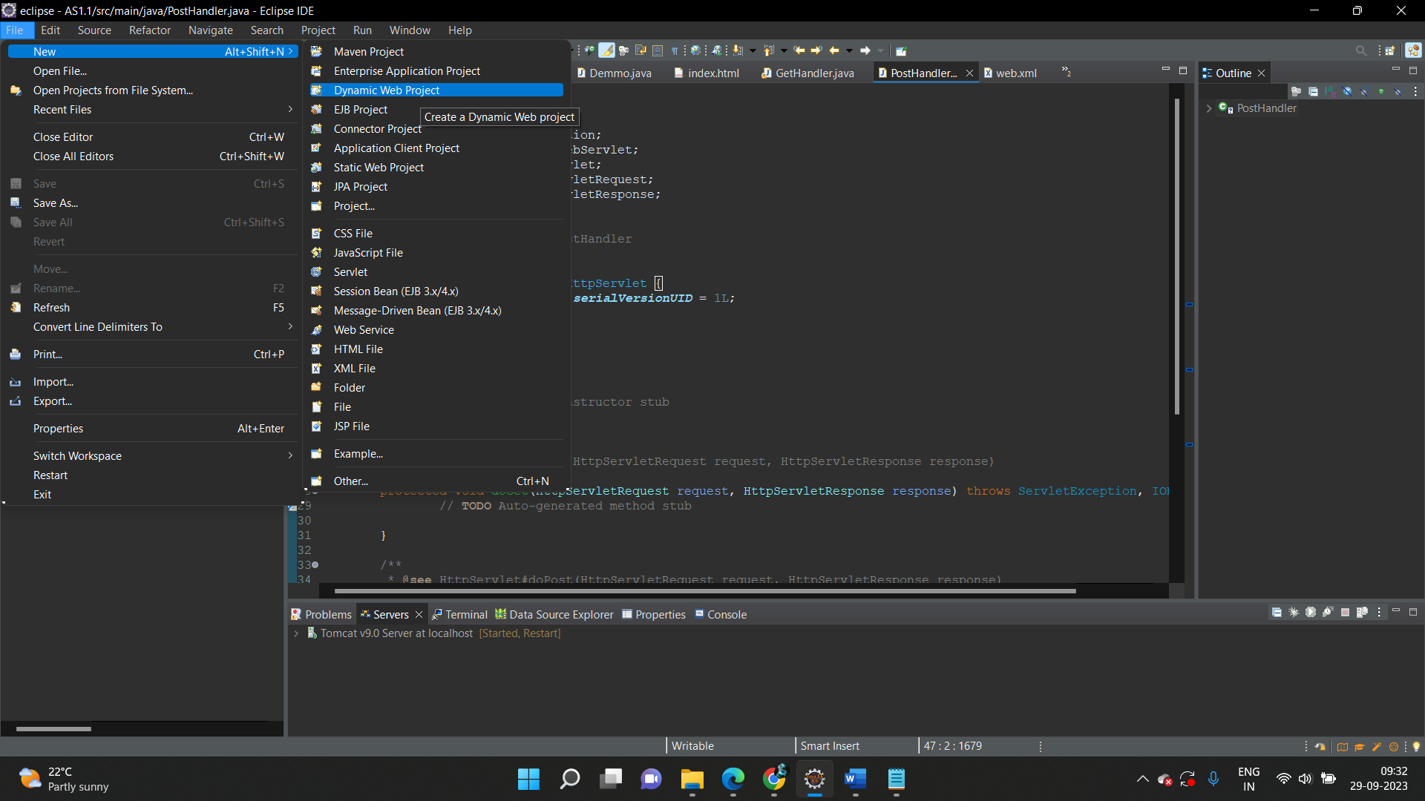

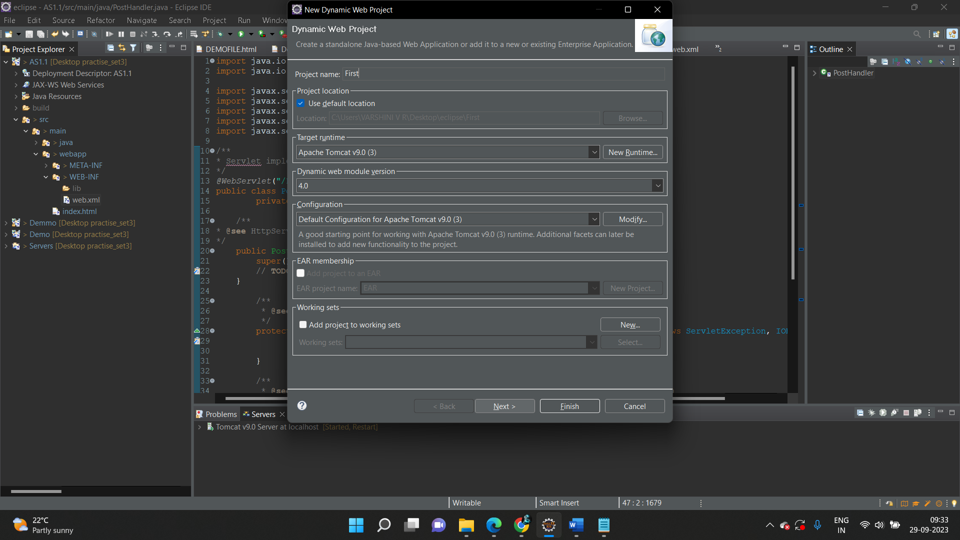

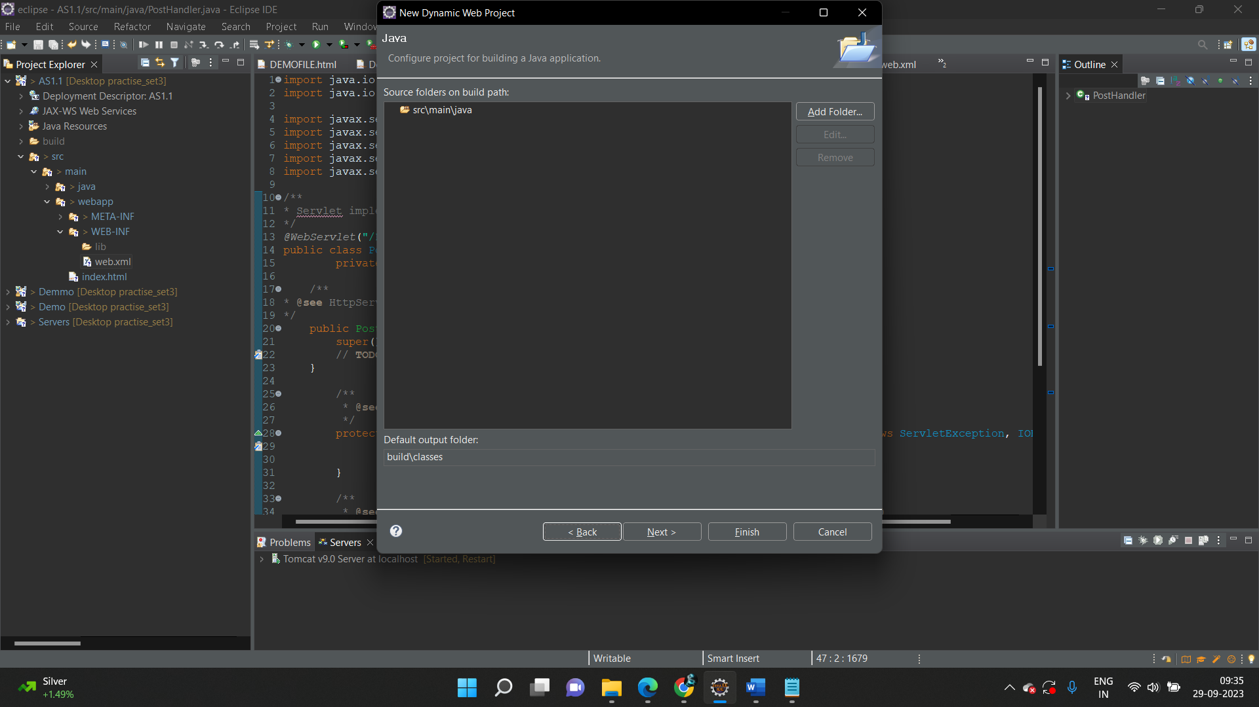

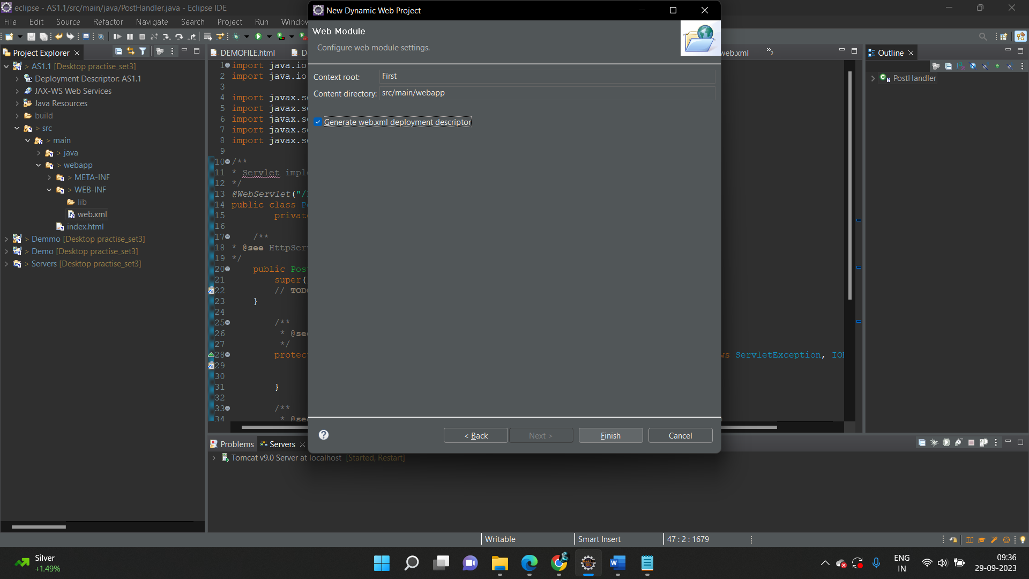

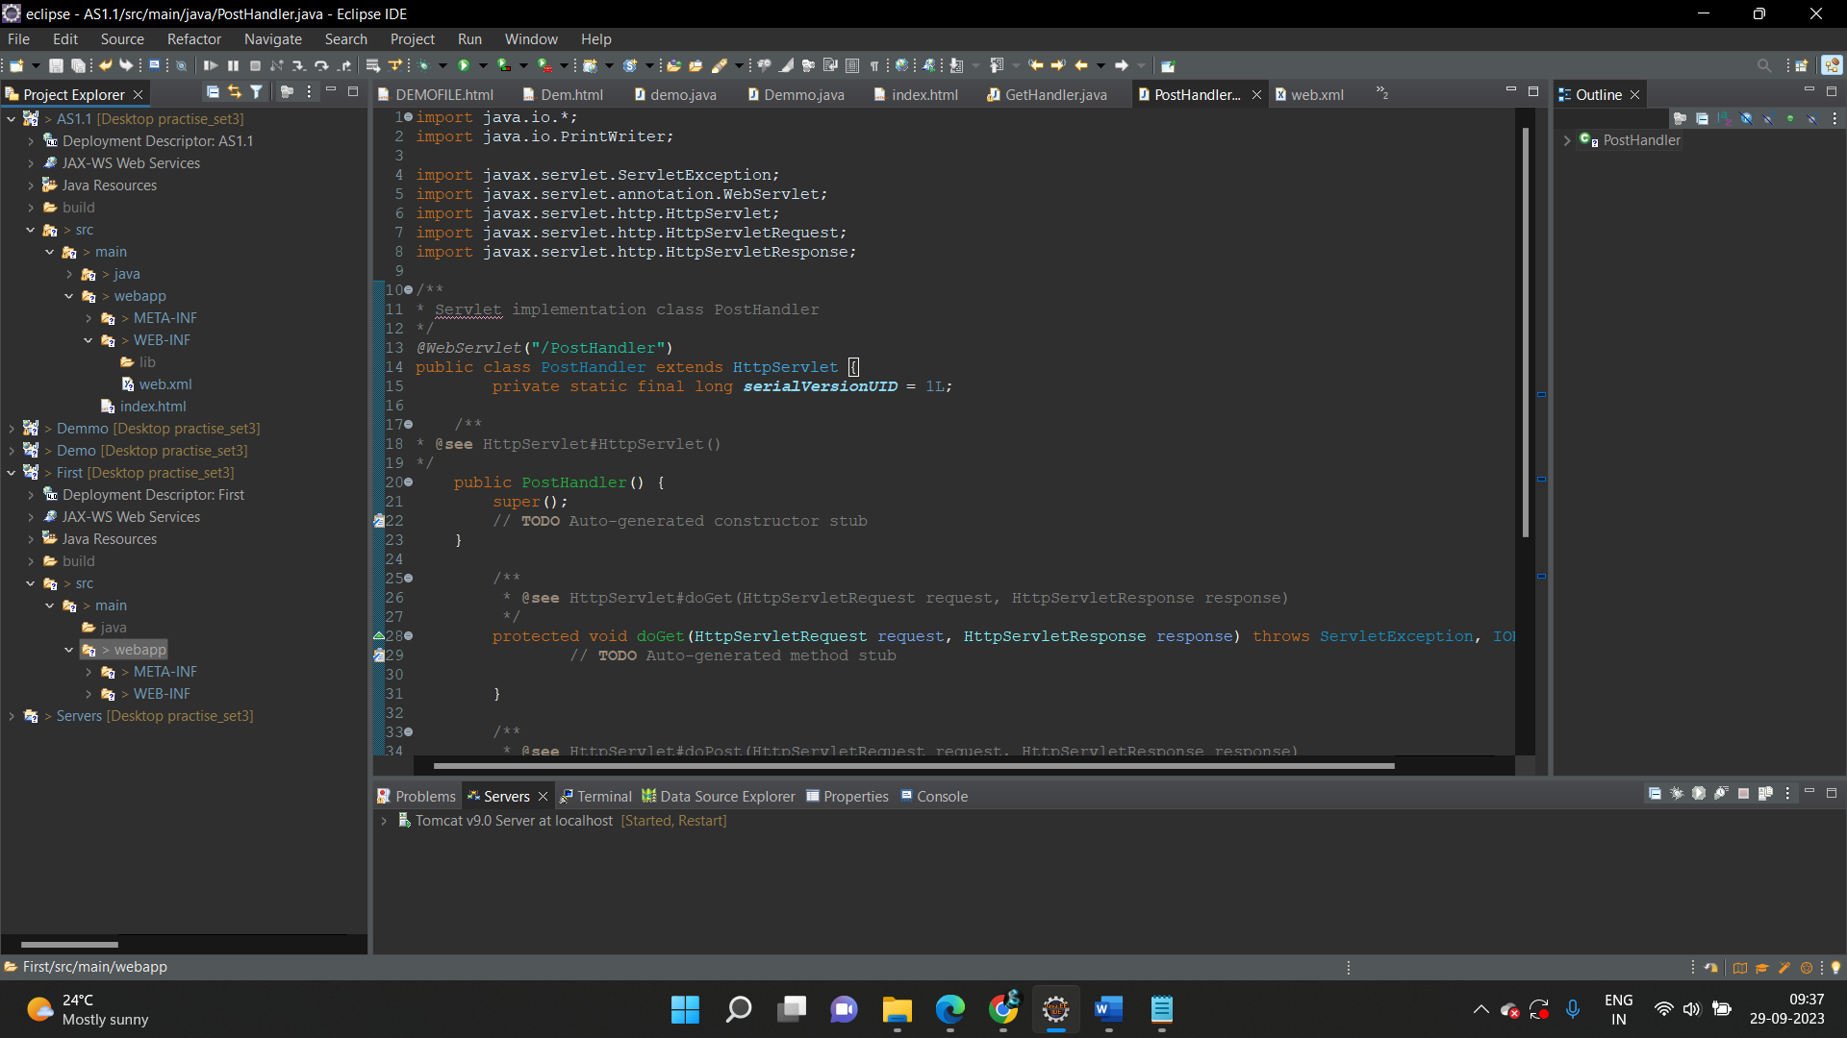



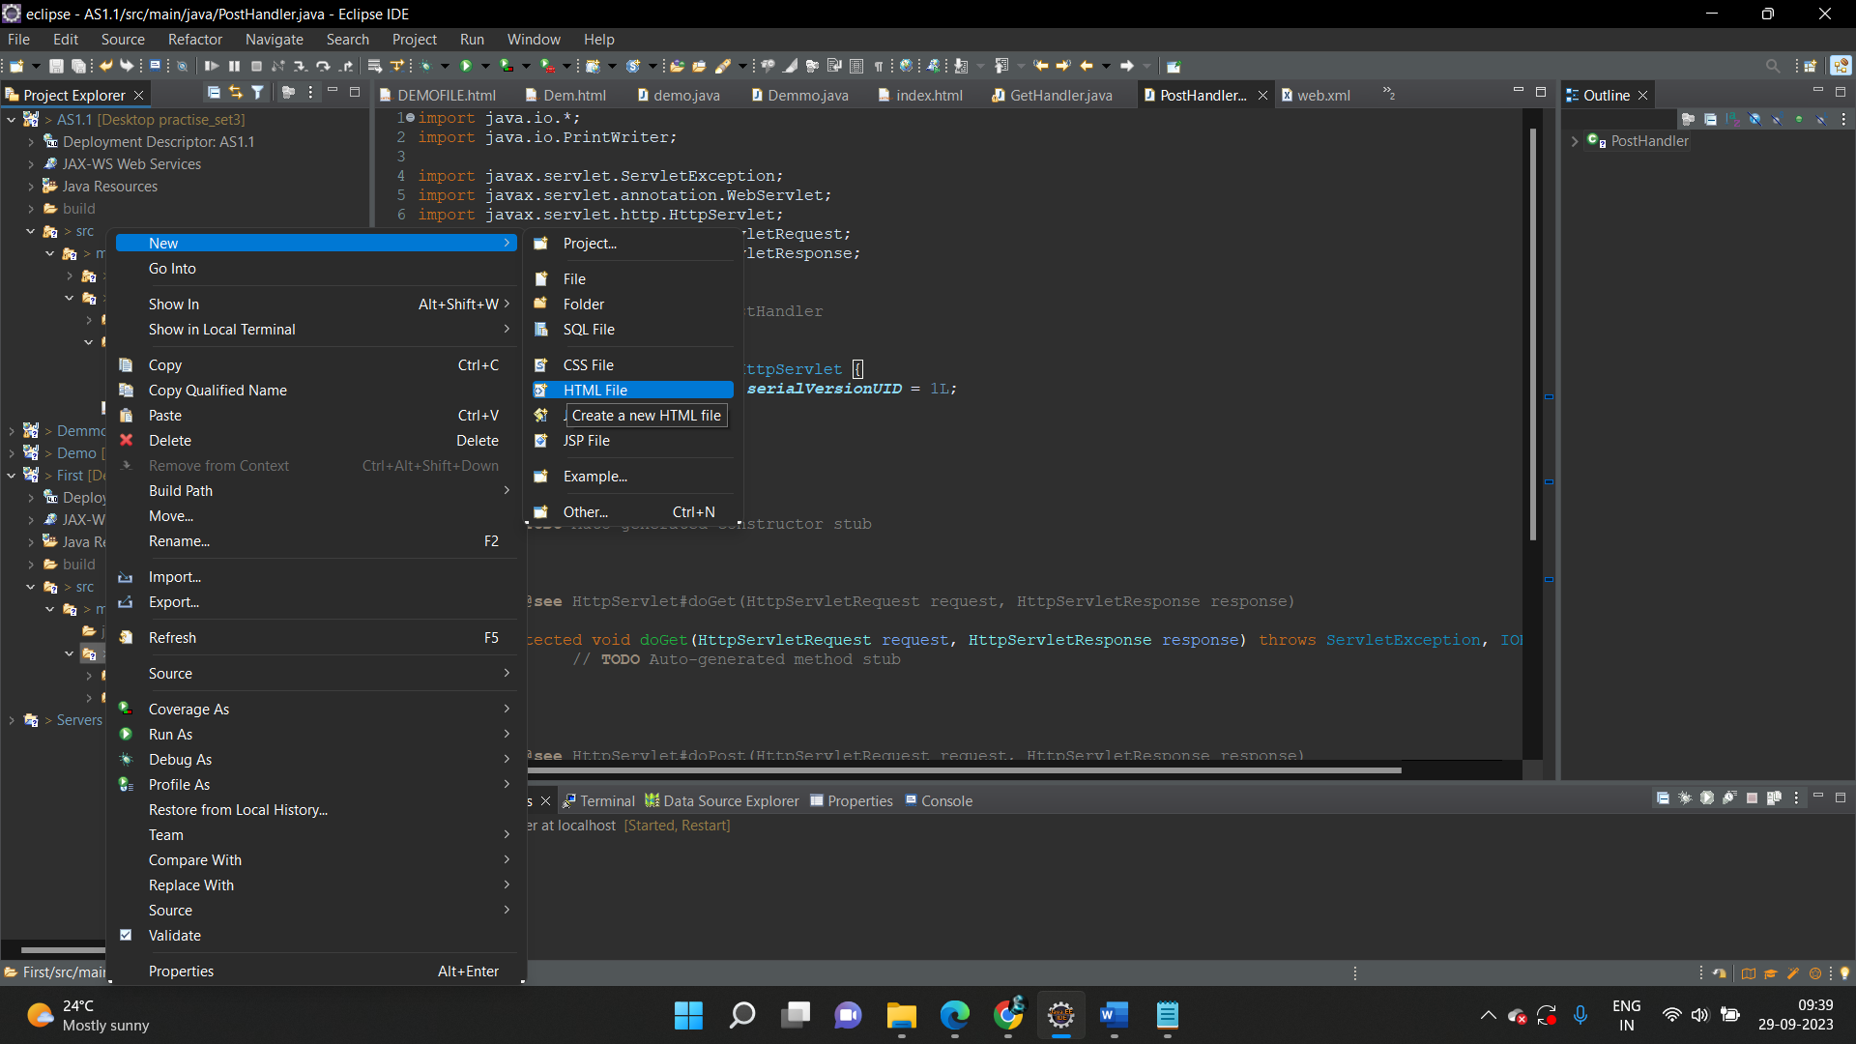

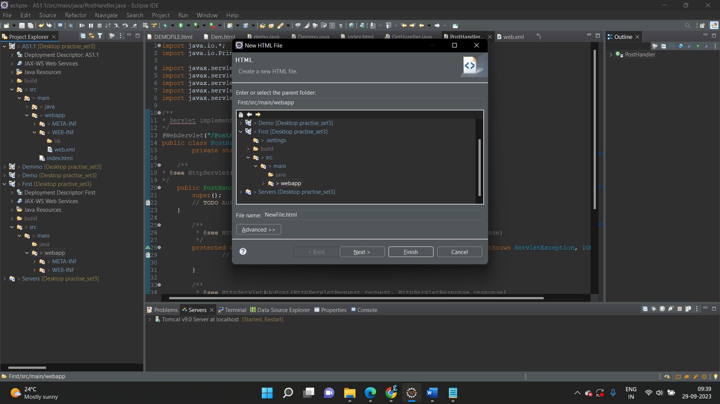

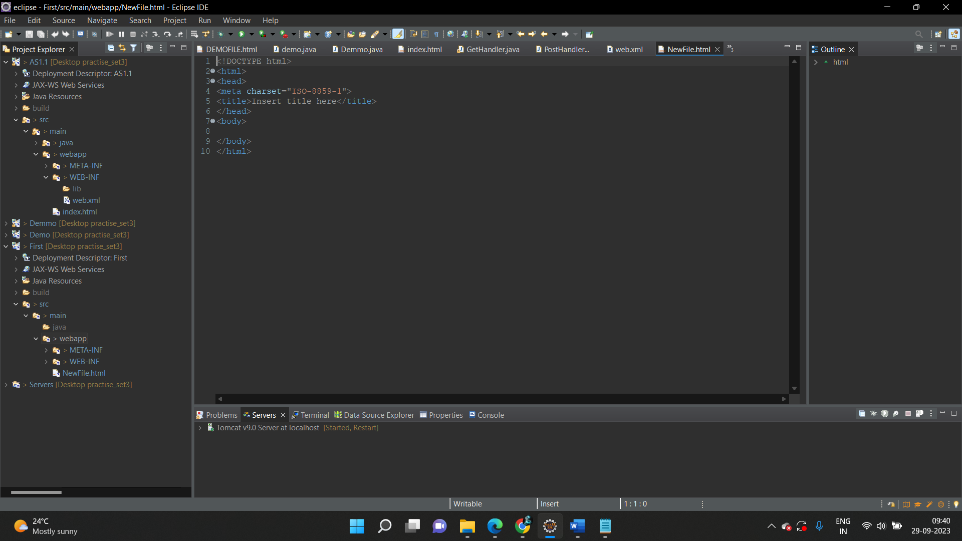

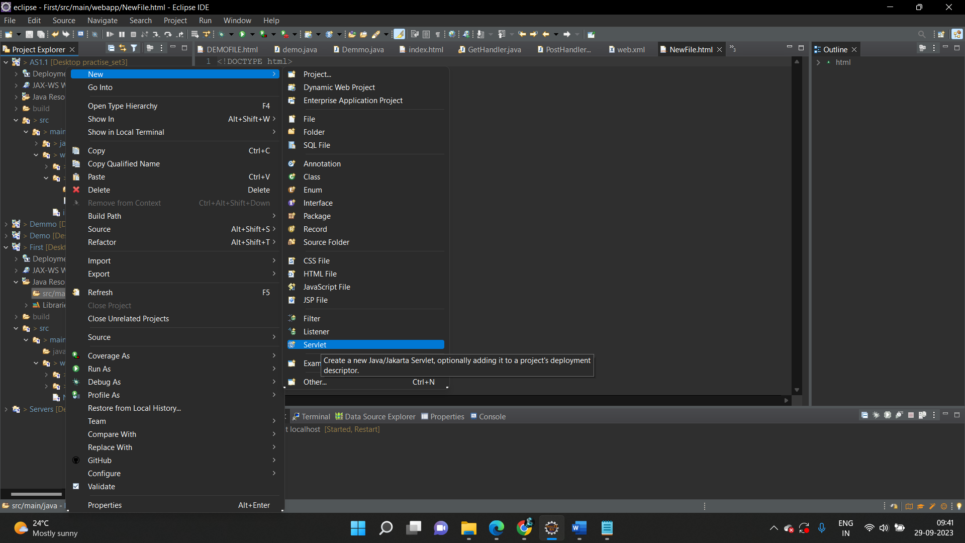

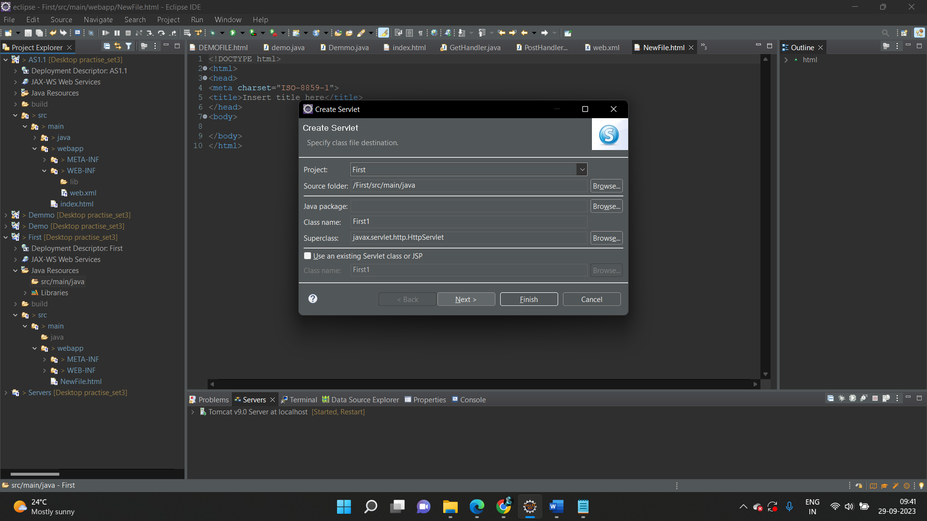

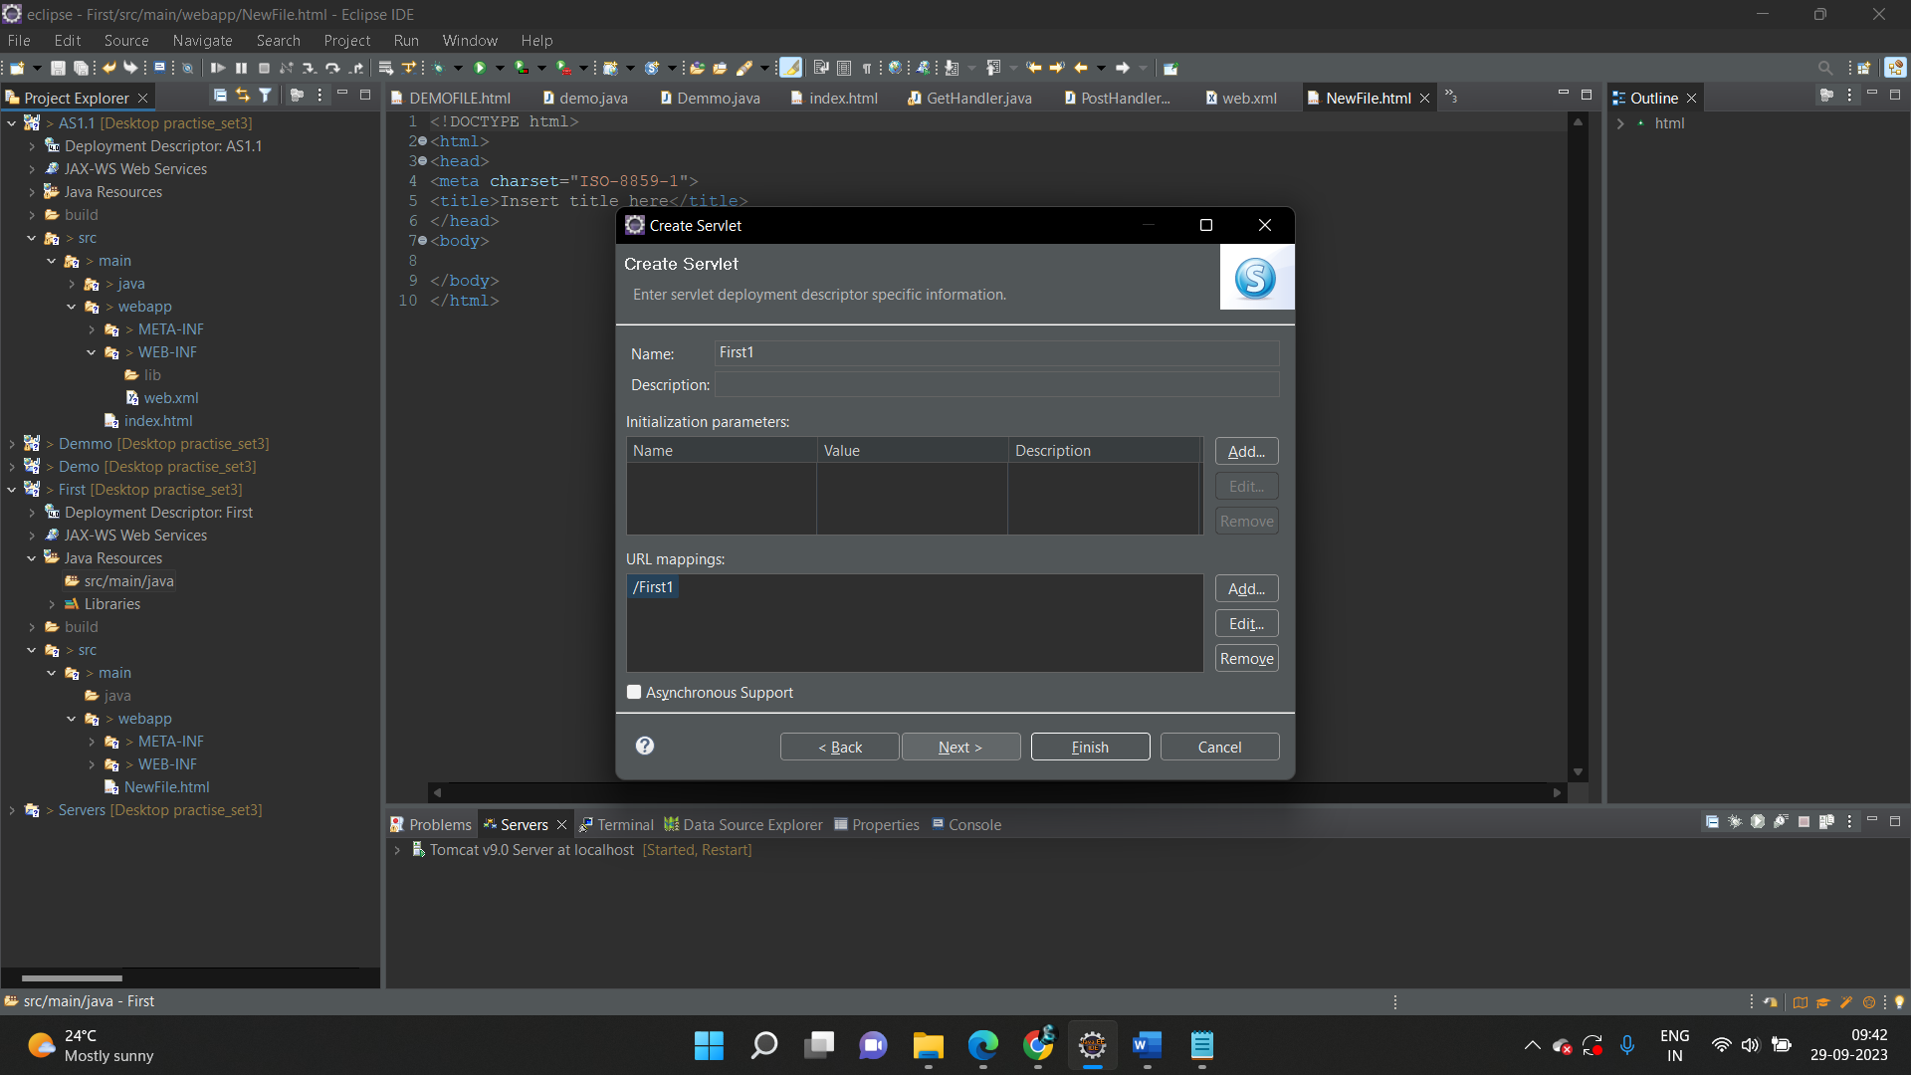

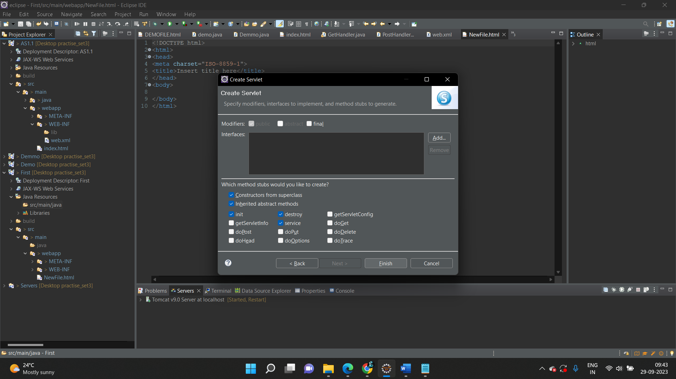

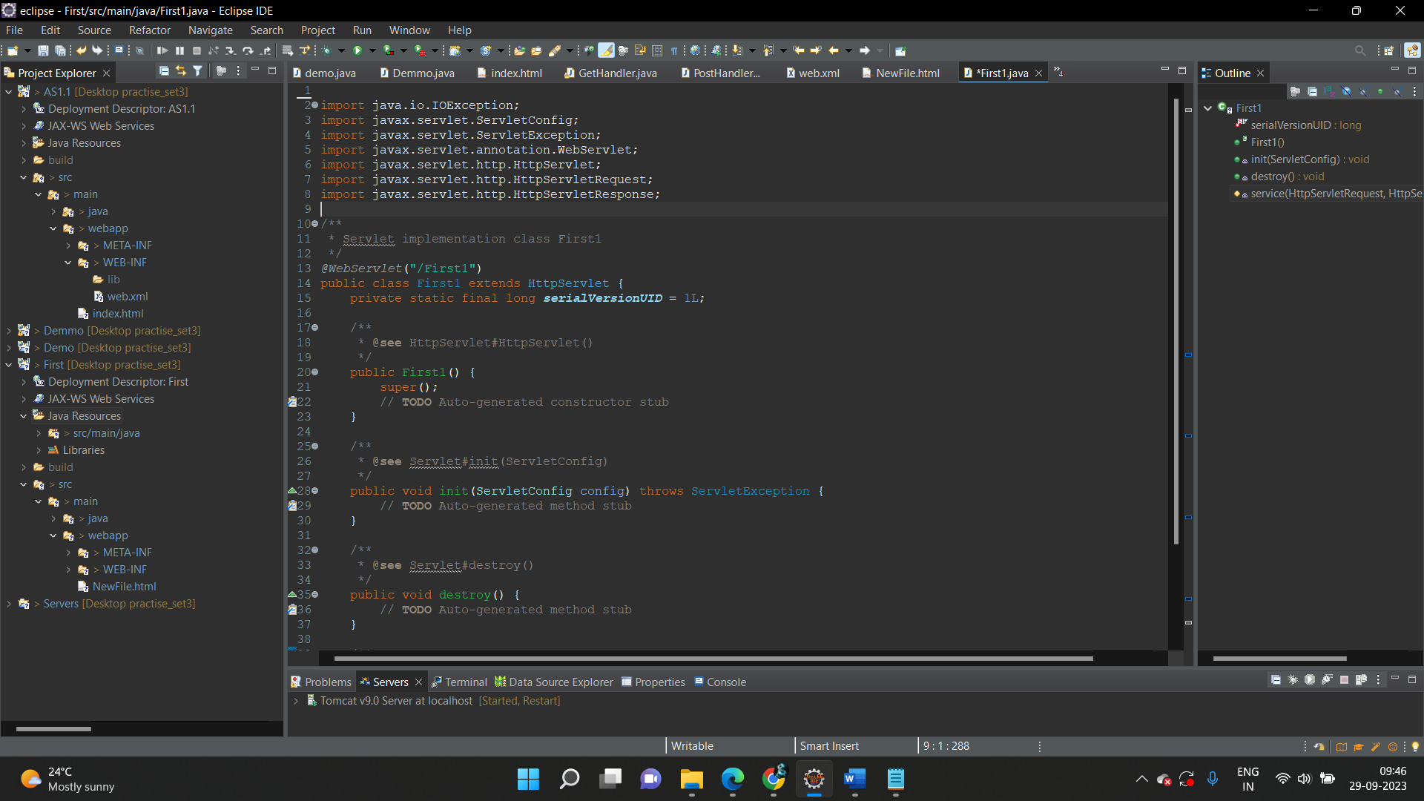

* To add it to the project, follow the below mentioned steps:
  + In the Project Explorer, right click on **FirstServlet** and choose **Properties**
  + Select **Java Build Path** from the options on the left
  + Click on **Libraries** tab on the right
  + Under **ClassPath,** expand the node that says **Apache Tomcat**
  + If there is an existing entry for servlet-api.jar, then click on **Cancel** and exit the window
  + If it is not there, then click on **Classpath** entry and click on **Add External JARs** button on the right
  + From the file list, select servlet-api.jar file and click **Ok**
  + Click on **Apply and Close**